**Market Analyst**

Collecting and Analysing by SeenPay Team

**Table of Content:**

1. **E-Commerce statistics report of Vietnam**
2. **The differences in E-Commerce of U.S and Asia market in general**
3. **The risk of shopping via Internet in Asia/Southeast Asia**
4. **Market entry barriers for new firms**

**E-Commerce statistics report:**

* According to the survey by Vietnam E-commerce and Information Technology Agency (VECITA) in 2014, the online purchases per person was estimated at about 145 USD, and B2C sales revenue reached 2.97 billion USD. These are just some of commonly purchased items online; furniture and electronics (60%), fashion and cosmetics (60%), appliances (34%), books, stationery (31%). In Vietnam, most online shoppers opt for cash on delivery that amounts to 64%. Other forms of payment i.e. via electronic wallets and bank accounts for 37% and 14% respectively.
* In addition, the survey indicated that 71% of respondents that purchased online through websites for goods or services increased by 10%, as compared to 2013. The number of people using social media for trading increased from 45% in 2013 to 53% in 2014. Whereas the number of people that purchased items via group buying websites, decreased by 16% to 35% in 2014. The remaining part of the survey showed, 25% of respondents purchasing via e-marketplace and 13% through applications on smartphones.
* Cash was the majority payment method for online transactions (64% of respondents), even though having decreased 10% when compared a earlier to 2014. Bank transfers also made decrease from 41% in 2013 to 14% in 2014. However, the number of people using electronic wallets grew 8% in 2013 to 37% in 2014.

**The differences in E-Commerce of U.S and Asia market in general:**

* E-Commerce in Asia/SEA is relatively new and rapidly growing everyday. As for the U.S. , its e-commerce sector is well developed with experienced online shoppers.
* The wide gap in culture differences is main factor for the lack of similarity in consumer behaviour between the two markets. Fundamental consumer behavior dissimilarities include establishing trust between buyer and seller, the product quality, and expectations from shopping online.
* The U.S’s infrastructure is strategically planned out and has many leading sustainable logistics companies that are reliable. Hence it is evident that, if asia were to have these aspects the complete potential of the e-commerce sector of developing countries in Asia can be fully harnessed.
* The absence of a standardised product quality control, and the vast variety of different products offered by untrustable sellers in Asia is posing a factor constituting Asian shoppers to not trust online shopping.
* Handling Internet security related issues in Asia is not at the same standing with how the U.S regulates/manages.
* Governments belonging to developing parts of Asia does not has the ability to take full control of the internet and E-Commerce business.
* Asian shoppers prefer having the items on hand to inspect and even try out just like trading in traditional business models before they make the decision to pay.
* Internet users and its usage in Asia is increasing gradually in ample rates. However, it still can’t keep up the the rates in the US.

**The risk of shopping via the internet in Asia/Southeast Asia**

* The risk of lost & damage in shipping items in Asia/SEA is higher than normal due to Infrastructure issues.
* There is no instant gratification. Because you have to wait a few days for the product is shipped to you.
* Product’s quality is not guaranteed and no return policy, consumer may receive an inferior product, product not as good as the description from untrusted seller.
* Sellers charge shipping fee.Though products are generally cheaper in online store, however the addition of the shipping fee makes the total price similar or more expensive than that.
* Internet security issue, online shoppers will be easy become a target of online scams and hackers. Fraud and Security concerns.There are some other problems that can occur, such as credit/debit card fraud, spyware. Merchants also risk fraudulent purchases using stolen credit cards or fraudulent repudiation of online purchase.
* There are products which better to buy from the traditional store like clothings or shoes because consumers need to try it first to see whether it fit them or not.
* There is no return policy or it is unclear. Returning an item is difficult when shopping online.
* Privacy of personal information. Buyer wish to avoid spam which could result from supplying contact information to an online merchant.

**Market disadvantage:**

* Shoppers feel hesitation to do online shopping due to the lack of knowledge and experience on e-commerce.
* The trust of consumers on online shopping or e-retailers is very tenuous.
* Cash on Delivery is dominate payment method in Asia.

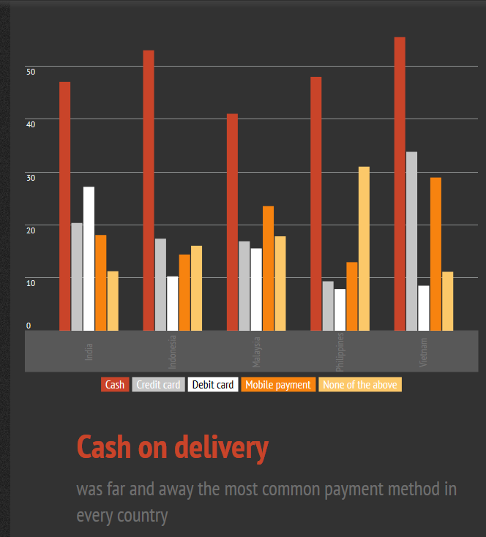source from: https://infogr.am/Online-Shopping-in-Emerging-Asia

Shopping online disadvantages per analyst by chart:

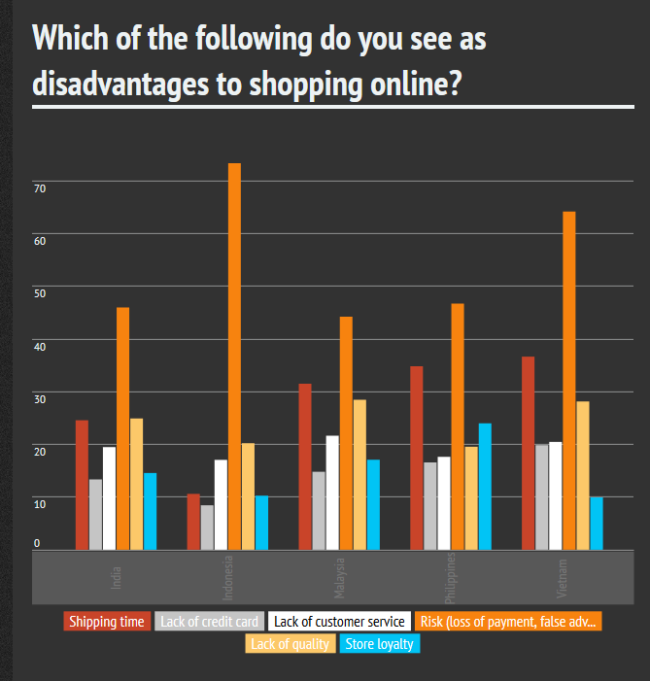

soucre: https://infogr.am/Online-Shopping-in-Emerging-Asia

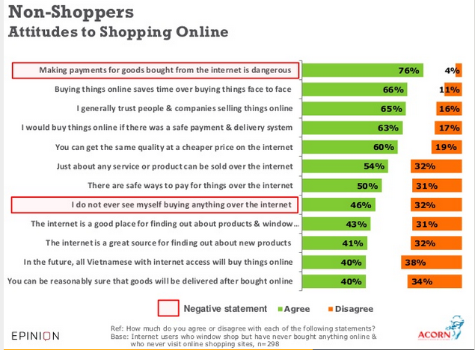

source: http://www.slideshare.net/reizarc/vietnamese-internet-users-online-buying-and-selling-behaviour

Summary:

* Two thirds of Vietnamese online shoppers access shopping site online and 45% do so on a desktop PC, only 22% use their smartphone and just 8% use a tablet.
* A staggering 88% have ever bought something online, with 20% claiming more than 25 purchase to date and a median of 8.75 purchases
* Average(median) spend on last item purchased was approx. VND 367,000(US$17.6), thought 8% said they spent over 5 million VND(US$240) but given poor access to credit and low bank usage in Vietnam, cash on delivery dominates e-commerce in Vietnam. Three quarters of last purchases were by COD to home and only 5% made by credit or debit card.
* Vietnamese online buyer feel comfortable buying online - with a plurality (38%) believing that online shopping is better than face-to-face shopping, while just 25% feel it is worse and two-thirds saying they will buy online again in future.
* Trust appears to remain a barrier among those who have never bought online three-quarters agree that making payments remains dangerous and less than half 40% agree that you can be reasonably sure of delivery if you buy something over the internet.

Source: **http://www.slideshare.net/reizarc/vietnamese-internet-users-online-buying-and-selling-behaviour**